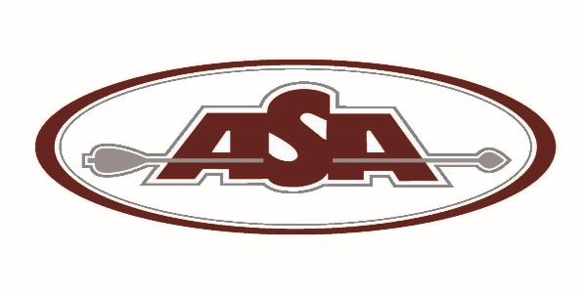

Archery Shooters Association
1301 Shiloh Rd Ste. 720
Kennesaw, GA 30144
770-795-0232 / 770-795-0953fax
jenny@asaarchery.com
www.asaarchery.com

ASA Club Insurance Renewal

RENEWAL PROCESS via Mail: Make sure all information is correct on the enclosed forms and return all four (4) forms (even if there are no changes) with payment to ASA by mail, email or Fax.

By Mail: ASA Federation, 1301 Shiloh Rd, Ste. 720, Kennesaw, GA 30144
By Email: jenny@asaarchery.com
By Fax: 770-795-0953

- CLUB CHANGE WORKSHEET - If changes are needed, please draw a single line through and write the correct information on the worksheet where indicated.

- CURRENT LANDOWNER INFORMATION - To update or add landowners list them on the Current Landowner Information sheet where indicated, and there is a $25.00 fee for each landowner listed.

- CLUB ROSTER - For member deletions strike through the name(s) on the club roster. To add members please complete and return the appropriate membership forms that are in this packet (make additional copies as needed.) Associate members are also listed on the roster and any changes to them are also needed.

- ASA CLUB REMITTANCE – Make all calculations on the form as shown. ASA recommends that your non-ASA club members purchase the ASA Associate membership for $20.00 to provide them with personal archery liability insurance. ASA offers filling out paperwork for the club by phone for an additional fee of $50.00, and ASA RUSH Same Day processing for an additional fee of $50.00.

Holding club Events and Hosting ASA Federation Events: Once processed and renewed you will be emailed your Certificate of Insurance along with the procedures for hosting an ASA State Qualifier.

ASA Federation competitions are designed to attract competitors to your club using ASA rules.

The national ASA office and all the ASA State Directors and Representatives are dedicated to the sport of 3-D archery and are working to make a difference with your help. We stand ready to assist your club as part of the future of our sport.

