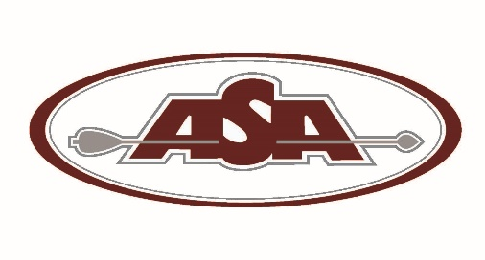

Archery Shooters Association
1301 Shiloh Rd Ste. 720
Kennesaw, GA 30144
770-795-0232 / 770-795-0953fax
jenny@asaarchery.com
www.asaarchery.com

ASA CERTIFICATION for NEW CLUBS

“The ASA Federation is dedicated to providing services and programs that will assist clubs in attracting members and maintaining their financial viability”

ASA Club Liability Insurance: For your club to be eligible for ASA Club Insurance, and the additional benefits that ASA clubs enjoy, (fill out the following attached forms and send them to the ASA office) (1) New Club Registration & Remittance; (2) Individual Membership/Family Membership form(s); (3) Landowner form; and (4) Associate Member form (refer to this form for associate member definition).

Explanation of ASA Club Insurance Requirements: Please refer to the next page for the Coverages, Limits and Exclusions for ASA coverage.

ASA insurance coverage runs from the calendar year January 1st and expires on December 31st each year.

- To qualify for ASA Club Insurance your club must have, or pay for, a minimum of ten ASA individual memberships.
- ASA Lifetime and Primary Lifetime Members may be counted toward the required ten members if they are not in another club.
- If your club does not currently have ten ASA members the club will be issued “membership certificates” that may be sold and/or awarded at the club’s discretion.
- Under an ASA Family Membership (a family consisting of head of household, spouse and dependents 21 years of age or younger) only the primary member is counted towards the club’s minimum of ten memberships.
- New club insurance coverage will begin upon issuance of a certificate of insurance effective January 1st for early applications, or within ten (10) days of the receipt of the application and full payment.

Holding club Events and Hosting ASA Federation Events: Once processed and approved as an ASA Club you will be emailed your Certificate of Insurance along with the procedures for hosting an ASA State Qualifier.

ASA Federation competitions are designed to attract competitors to your club using ASA rules.

The national ASA office and all of the ASA State Directors and Representatives are dedicated to the sport of 3-D archery and are working to make a difference with your help. We stand ready to assist your club as part of the future of our sport.

